Practical No.6

Write a program that implements RR scheduling algorithm.

Input:-

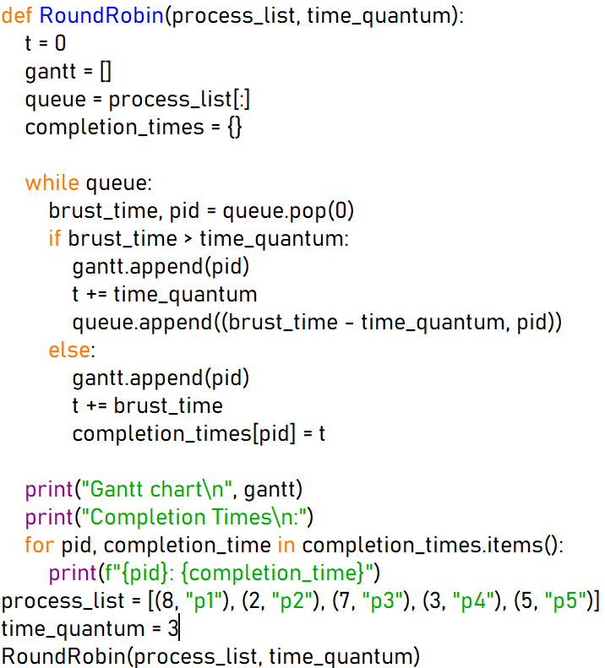

Output:-

